LINKTOP CONFIDENTIAL

Security： | Confidential | Version： | V1.0
Scope： | Customer | Status： | Released

HC03 Flutter SDK API Guide

File No. | LT-SW-24062401 | Type | RD
Written： | Chenzq | Date： | 2024-6-24
Check： | Yangxd | Date： | 2024-6-24
Approval： | Tangzp | Date： | 2024-6-24


Linktop Technology Co., Ltd

- Records
LINKTOP CONFIDENTIAL

Version | Date | Remarks
V1.0 | 2024.06.24 | First version

- Table of Contents
LINKTOP CONFIDENTIAL
- INTRODUCTION 4
  - Engineering Development Description 4
  - Integration Steps 4
    - Android 4
    - iOS 4
- API DESCRIPTION 5
  - Function Description 5
  - Flow Chart 5
  - External Interface 5
    - Initialization 5
    - Start 6
    - Stop 6
    - Callback 7
    - ECG 7
    - Blood oxygen 8
    - Glucose 9
    - Blood pressure 10
    - Battery 10
    - Body temperature 11

Introduction
LINKTOP CONFIDENTIAL

Engineering Development Description
- Bluetooth outsourcing, unpacking, and data processing are encapsulated in the lib/src/core directory, and the external API is in the hc03_sdk_impl.dart file
- The Bluetooth library is encapsulated in the lib/src/bluetooth directory, and the external API is in the bluetool_manager.dart file
- The call to the function is located in the lib/src/pages_data/health_data.dart file.

Integration Steps

Android

- Porting the jar package of Android/app/libs/NskAlgoSdk.jar and the Java files in the Android/app/src/main/Java/com/ecg folder, as well as the So library and Android/app/src/main/kotlin/com/example/smart_flutter/EcgPlugin.kt files in the Android/app/src/main/jniLibs folder to your project
- Initialize EcgPlugin in the configureFlutterEngine method of MainActivity in your project Android. Please refer to Android/app/src/main/kotlin/com/example/smart_flutter/MainActivity.kt
Remember to add permission references to Android/app/src/main/AndroidManifest.xml in AndroidManifest.xml
Please refer to the android/app/build.gradle file for the dependency on NskAlgoSdk. jar and the setting of the jniLibs path that needs to be added in the android/app/build.gradle file.

iOS

- Porting the files and .a library from the ios/Runner/libNSKAlgoSDECG folder, as well as the ios/Runner/SDK Health Monitor.h and ios/Runner/SDK Health Monitor. m, to your project.
Note that the .a static library needs to be added in Target ->Build Phases ->Link Binary With Libraries in xcode, and then in Target ->Build Setting ->Other Link Flags, add - all'load (the .a library is located in libNSKAlgoSDECG).
- To initialize SDKHealthMonitor in ios/Runner/AppDelegate.h and ios/Runner/AppDelegate.m, please refer to the demo for ios/Runner/AppDelegate. h and ios/Runner/AppDelegate.m.

API Description
LINKTOP CONFIDENTIAL

Function Description
SDK establishes a connection with the device through BLE. You can easily communicate with the device through the SDK and extract services such as electrocardiogram, blood oxygen, and body temperature data provided by the device.

Flow Chart

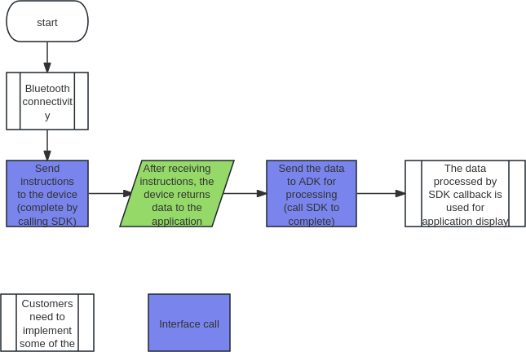

External Interface

Initialization

Initialize where you need to use interfaces
Hc03Sdk sdk=Hc03Sdk.getInstance();

Start
LINKTOP CONFIDENTIAL

Function
startDetect(Detection detection);
Call startDetect to start the test interface after Bluetooth connection

- Parameter
  - Detection.BT: Temperature
  - Detection.OX: Blood oxygen
  - Detection.ECG: Electrocardiogram
  - Detection.BP: Blood pressure
  - Detection.BATTERY: Battery
  - Detection.BG: Blood sugar
- Sample Code
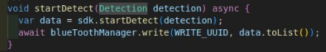

Stop

Function
stopDetect(Detection detection);
Call stopDetect to stop the testing interface

Parameter
  - Detection.BT: temperature
  - Detection.OX: Blood oxygen
  - Detection.ECG: Electrocardiogram
  - Detection.BP: Blood pressure
  - Detection.BG: Blood sugar

Sample Code
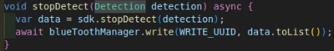

Callback
LINKTOP CONFIDENTIAL

Function
parseData(data);

Parameter
data: Bluetooth callback data

Sample Code
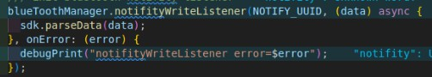

ECG

Function
getEcgData;

Callback data type
  - Wave: Data used for drawing waveforms
  - HR: Heart rate data
  - Mood Index: Mood Index 1-20: chill
21-40: relax
41-60: balance
61-80: excitation
81-100: Excitement/Anxiety/Excitement
  - RR: Peak to peak value
  - HRV: Heart rate variability
  - RESPIRATORY RATE：Respiratory rate
  - touch: Finger detection

Sample Code

LINKTOP CONFIDENTIAL
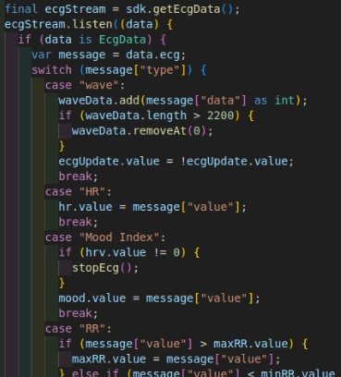

Blood oxygen

Function
getBloodOxygen;

Callback data type
  - BloodOxygenData: bloodOxygen: Blood oxygen
heartRate: heart rate
  - FingerDetection: Finger detection
  - BloodOxygenWaveData: Draw waveform data

Sample Code

LINKTOP CONFIDENTIAL
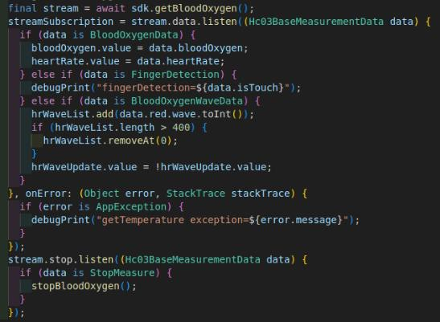

Glucose

Function
getBloodGlucoseData;

Callback data type
  - BloodGlucoseSendData:Data to be sent to the device
  - BloodGlucosePaperState: Blood glucose test strip status information during the measurement process
  - BloodGlucosePaperData: Blood glucose data

Sample Code
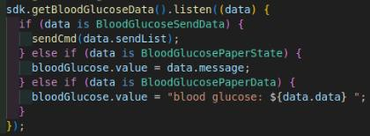

Blood pressure
LINKTOP CONFIDENTIAL

Function：
getBloodPressureData;

Callback data type：
  - BloodPressureSendData:Data to be sent to the device
  - BloodPressureProcess: Display the process of blood pressure measurement
  - BloodPressureResult: Blood pressure data ps: systolic pressure
pd: diastolic pressure hr: heart rate

Sample Code：
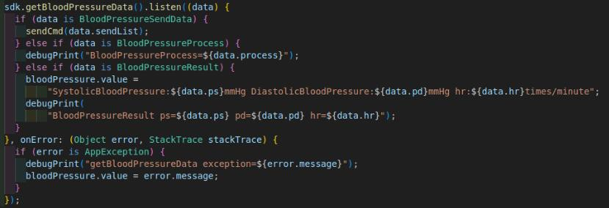

Battery

Function：
getBattery;

Callback data type：
  - BatteryLevelData: Battery percentage data
  - BatteryChargingStatus: Battery charging status

Sample Code：

LINKTOP CONFIDENTIAL
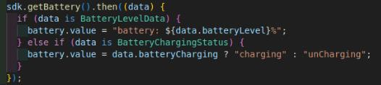

Body temperature

Function：
getTemperature;

Callback data type：
TemperatureData: Body temperature data

Sample Code：
